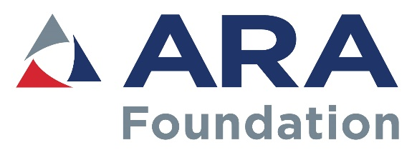
FOR OFFICE USE ONLY:

Date Received: _____________
ARA Co. ID #: _____________
ARA Member ______________

Employee Training Assistance Program Application
Assistance to be awarded quarterly
Application deadlines: March 31, June 30, September 30, December 31
ASSISTANCE IS INTENDED TO AID EMPLOYERS IN PROVIDING TRAINING TO EMPLOYEES. EMPLOYERS MUST COMPLETE AND SUBMIT THE APPLICATION.

REQUIREMENTS:
- Training MUST support a career in the equipment/event rental industry. Examples of training include:
Leadership | Financial | CERP | Marketing & Sales
Time Management | Problem-solving skills | Driving (CDL) | Hospitality
Vendor Training | Customer Services Training | Technical (mechanical, electrical, etc.
Other: (Please explain)

- Employees need a minimum of 1,000 hours of service with the employer to qualify.
- Assistance will be up to 50% of the training cost, with a maximum award of $1,000.
- Assistance will cover only the cost of the training (no travel, tools or supply costs).
- Assistance may be approved prior to completion of training, but funding will be disbursed following training completion.
- A Certificate of Completion is required to receive the awarded funds.
- Training must be completed six months from the date of award. Exceptions will be considered on a case by case basis.
The information requested will be kept confidential and is for the sole purpose of grant selection. It will be accessible only to the ARA Foundation Staff and Employee Training Assistance Program Committee.
For questions, please contact:
April Kleckner, Foundation Program Manager
april.kleckner@ararental.org
800.334.2177, ext. 234, or 309.277.4234

Applications must be received or post marked by the deadline date to be considered for that quarter. Applicants will be notified of the status of the application within 30 days of the deadline.

SECTION 1: COMPANY INFORMATION (Please type or print clearly)

Company name:

Employer name:
 | Last Name | First name
Mailing address:
 | City | State |  | Zip
Phone: | ( ) | Cell: | ( )
Email address:

SECTION 2: EMPLOYEE INFORMATION

Employee name:
 | Last Name | First Name | M.I.
Position: |  | Date of hire:
Cell: | ( )
Email address:

SECTION 3: TRAINING INFORMATION

School or training facility:
Type of training:

Date of training: |  | Trade/Technical/Vocational school  Community college (trade/technical/vocational certification program only)  Other: ______________________________________________________
Cost of training:
Diploma or certificate you will receive:
Completion date: |  |  | Score (if completed):
Attach description of the training program, including dates of classes, cost and receipt of payment.
Describe the training your employee attended and how this will benefit your business:

PLEASE READ CAREFULLY BEFORE SIGNING
This application is made for the purpose of obtaining an ARA Foundation assistance. I declare that all information set forth in this application is true and represents the facts as I know them. I understand ARA Foundation assistance funds will be sent directly to the business address listed on the application. If selected to receive assistance, I authorize the Foundation to use my name for marketing purposes. All decisions by the Employee Training Assistance Committee are final.

___________________________________ _______________________________
Signature of Applicant (Employer) Date
Submit application and supporting documents to:
ARA Foundation
1900 19th St.
Moline, IL 61265
Fax 309.277.4207
april.kleckner@ararental.org

